Walkthrough: LinkVortex HTB Machine
This report details the penetration test of "LinkVortex," a retired HackTheBox machine. The objective was to gain user access and retrieve the user flag.
1. Initial Reconnaissance and Service Enumeration
An Nmap scan was performed on the target machine, revealing two open ports:
- Port 22/tcp: Running SSH.
- Port 80/tcp: Running Apache.
The domain name was added to the /etc/hosts file. Initial web reconnaissance included checking /robots.txt, which revealed a hidden directory /ghost leading to an authentication page. However, no credentials were available at this stage.

2. Subdomain Enumeration and Git Repository Discovery
ffuf was used for subdomain enumeration, which identified the dev subdomain. The command used was ffuf -w /usr/share/wordlists/amass/bitquark_subdomains_top100K.txt -H "Host:FUZZ.linkvortex.htb" -u http://linkvortex.htb -ic -fs 230. The -ic flag was used to ignore case sensitivity, and -fs 230 filtered out "not found" errors.
Further directory enumeration on http://dev.linkvortex.htb using gobuster revealed a .git directory. The command used was gobuster dir -u http://dev.linkvortex.htb -w /usr/share/wordlists/seclists/Discovery/Web-Content/common.txt.
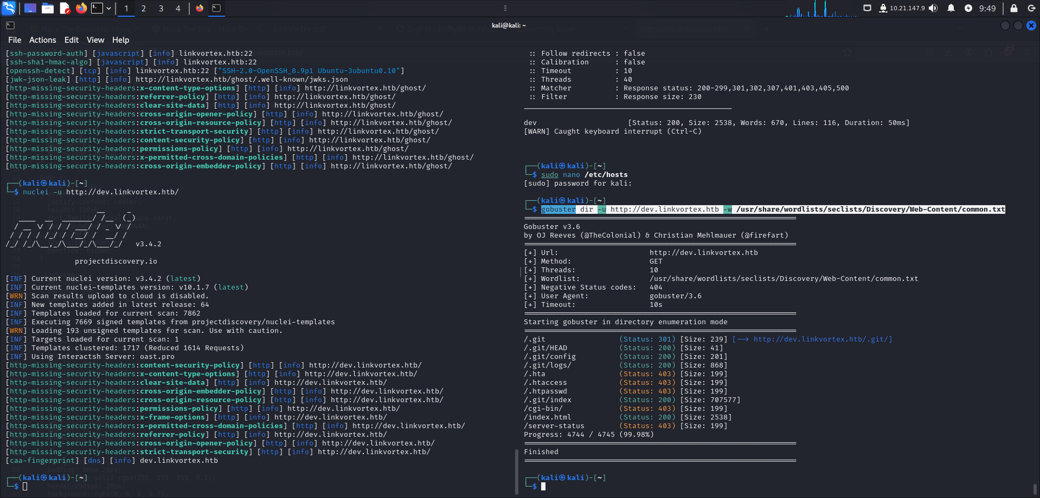
3. Gaining a Foothold - Git Repository Dump and Credential Disclosure
The .git repository was dumped, and by examining the git status, a committed change to authentication.test.js was discovered. Restoring this file revealed the password for admin@linkvortex.htb using grep -r 'pass' ../../../../../ghost/core/test/regression/api/admin/authentication.test.js.
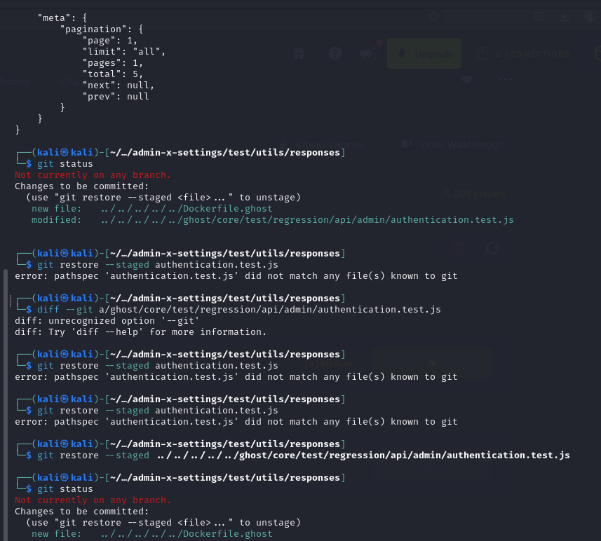
4. Lateral Movement - Arbitrary File Read and User Flag Retrieval
Inside the system, it was identified that the application was running version 5.58.0, which is vulnerable to an Arbitrary File Read (CVE-2023-40028). A Proof-of-Concept (POC) for this vulnerability was used to gain further access, which also revealed another username, bob, with the password fibber-talented-worth.
SSH access was then established using bob's credentials, and the user flag was successfully retrieved.

